Getting Started

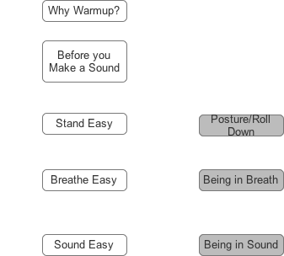

[Key – white button = text
Grey button = sound file
Blue button = plugin]
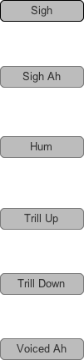
Mini Vocal Warmup – Individual Exercises

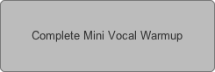
The Complete Mini Vocal Warmup

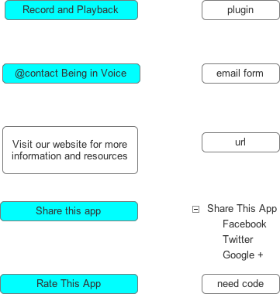
Extra

